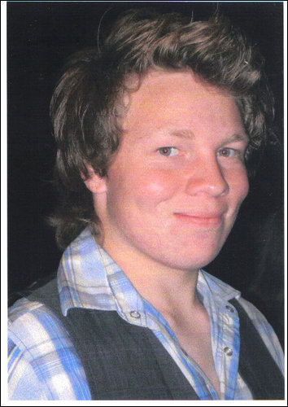

Pitbull Samba
Choreographers: Sandy Kerrigan & Travis Taylor (5/09)
Music: I Know You Want Me by Pitbull
40 Counts, Intermediate Line Dance, 3 Restarts
Rotation: ¼ Left

 | ROCK BACK REPLACE, CROSS ¼ BACK, ROCK BACK/REPLACE, SCUFF STEP OUT, SCUFF STEP OUT
1-2  3&4  5-6  &7  &8 | ROCK R BACK, REPLACE WEIGHT ON L  CROSS R OVER L, ¼ TURN R STEP BACK L, STEP BACK ON R  ROCK BACK ON L, REPLACE WEIGHT ON R  SCUFF L FWD SLIGHTLY TO L SIDE, STEP L DOWN  SCUFF R FWD SLIGHTLY TO R SIDE, STEP R DOWN (FEET APART)
 | LEFT CROSS SAMBA, CROSS SIDE, CROSS SIDE, CROSS SHUFFLE
1&2  3-4-5-6  7&8 | CROSS L OVER R, STEP BALL OF R TO R SIDE, REPLACE WEIGHT ON L  CROSS R OVER L, STEP L TO L SIDE * CUBAN HIP ACTION * CROSS R OVER L, STEP L TO L SIDE  CROSS R OVER L, STEP L TO L SIDE, CROSS R OVER L
 | CROSS, BACK, SCOOT/HOP, STEP BACK, BACK, ROCK/REPLACE, LOCK SHUFFLE FORWARD
1-2&  3-4  5-6  7&8 | CROSS L OVER R, STEP BACK ON R, SCOOT/HOP BACK ON R FOOT (&HITCHING L)  STEP BACK ON L, STEP BACK ON R  ROCK BACK ON L, REPLACE WEIGHT ON R  STEP FORWARD ON L, LOCK R BEHIND L, STEP FORWARD ON L
 | PIVOT ½, HIP AND HIP, HIP AND HIP, SIDE ROCK REPLACE
1 2 | STEP FWD R – 1-2 PIVOT TURN L (wt to L)
3&4 5&6 | HIP BUMPS FACING SIDE R45° R-L-R, HIP BUMPS FACING SIDE L45° L-R-L
7 8 | ROCK R SIDE, REPLACE ON L***
 | RIGHT CROSS SAMBA, CROSS SIDE, CROSS SIDE, CROSS SHUFFLE
1 & 2 | CROSS R OVER L, STEP BALL OF L TO L SIDE, REPLACE WEIGHT ON R
3-4-5-6 | CROSS L OVER R, STEP R TO R SIDE *CUBAN HIP ACTION* CROSS L OVER R, STEP R TO R SIDE
7&8 | CROSS L OVER R, STEP R TO R SIDE, CROSS L OVER R
40 | START DANCE AGAIN
*R* Restarts happens on the 3rd, 6th and 9th sequenced at count 32***
NOTE: Diagonal hips 3&4 – 5&6 can be danced a3a4,a5a6!! Dance with bounce action!!!!
CONTACT US
Sandy Kerrigan  0412 723 326  lassoo@optusnet.com.au  http://www.kerrigan.com.au/ | Travis Taylor  0431 382 782  Footloose_69_travio@hotmail.com  www.travistaylor.weebly.com

